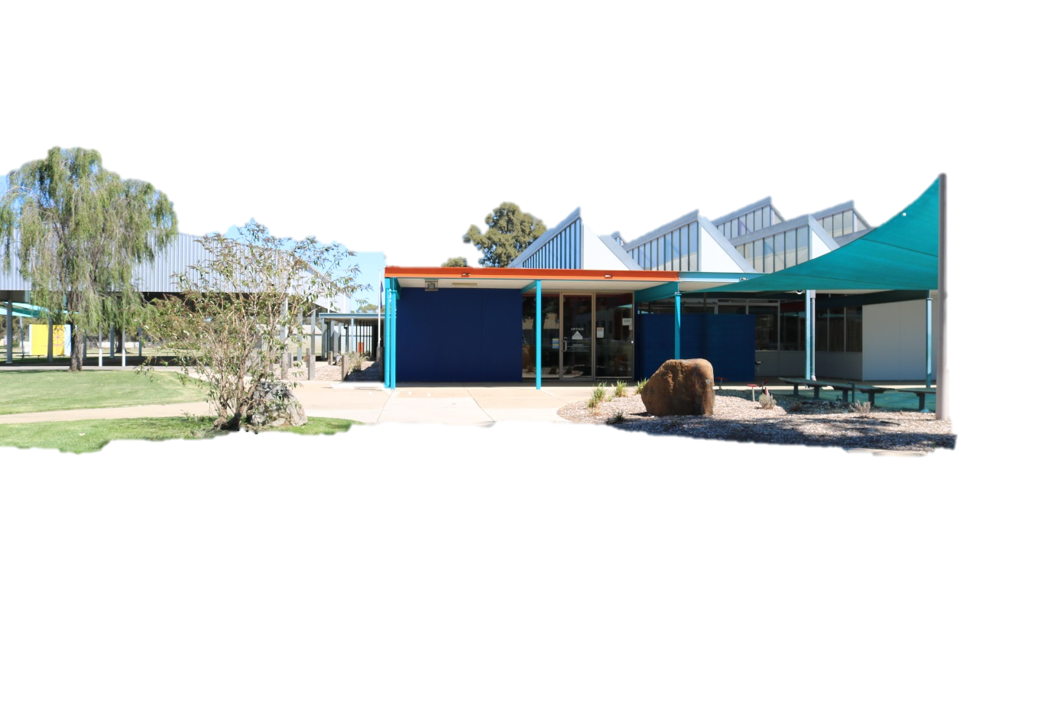

***Cohuna Consolidated School***

**CURRICULUM CONTRIBUTIONS**

Thank you to the families who have already paid their Curriculum Contributions for 2022.

Payments can be sent in with your child, made over the phone by contacting the office on 5456 2361 or in person.

**Years Prep – 2 $100.00 Years 3 – 6 $140.00**

**Facsimile Number: 5456 4044 Email:** [**cohuna.cs@education.vic.gov.au**](mailto:cohuna.cs@education.vic.gov.au) **Website: www.cohunacs.vic.edu.au**

Dear Families and Friends,

**Welcome back**

Welcome back to all our students and staff for Term 3! The holidays have been a mixed experience, with some people having a relaxing break and others experiencing sickness as we go through yet another wave of Covid and flu. Our staff as well as replacement teachers have also been affected so minimising disruption to learning is our absolute priority. I would like to thank all our staff for being so adaptable as we work our way through the current Covid/flu wave and would like to wish everyone who is currently unwell all the best for a prompt and fast recovery.

**Masks and RATs**

Given the current wave of Covid and the fact the new Omicron sub-variants are reported as more transmissible, the Department of Education is encouraging everyone to wear masks again when we are indoors. On our end, we will continue to use ventilation, air purifiers as well as hand sanitiser.

Please note that RAT tests will be now issued only to students who are symptomatic or close contacts.

**Vaccination**

There are no longer mandatory vaccination requirements for staff or visitors in mainstream schools, but it continues to be highly encouraged.

**Grade 6- Thank you**

I would like to commend our Grade 6 students for organising recess and lunchtime activities for our younger students. All the kids involved are enjoying the various games.

**Carpet**

The remaining carpet/vinyl works were completed over the holidays, covering areas such as the library, our tutor room and sick bay. A huge thank you goes to our Grade 6 leaders and helpers as well as staff who took everything out of the library and back into it. This was a big job! A huge thank you to Karl who put everything else back into the various rooms and made sure our building and grounds looked fantastic.

**Aquatic Strategy**

Consultation has taken place with schools regarding the proposed Aquatic Strategy, and I conveyed the importance of local pool access for our community to develop key swimming skills and water confidence in an area surrounded by water. A pool is also a community hub and a family friendly option. We sent a link to all parents via Compass to respond to an Aquatic Strategy survey, with the actual document attached. I encourage you to fill in this survey to ensure our local aquatic needs are fully met.

Kind regards,

Valerie Lobry

**Newsletter No 11 14th July 2022**

***Caring & Commitment leads to Success***

***Phone Numbers: 5456 2361 & 5456 2355 (Canteen 5456 2121) Acting*** *Principal: Valerie Lobry*

REMINDER

DATES

Cohuna Consolidated school

COHUNA CONSOLID

**BALLARAT & KOOKABURRA CAMPS:**

A further payment of $100.00 was due for the Grades 3/4 and 5/6 camps last term; June 24th, 2022.

If you are unsure of the amount you owe for the camp, please contact the school’s office.

**COMPASS-ENTERING ABSENCES:**

We still have a number of families who are not entering their child’s absences on the Compass App. Schools are audited by the department randomly on Student Records/Attendance and absences.

If your child has a number of unexplained absences due to parents not entering the absence on Compass, the child is flagged and the school has to get the family to provide information on the absence.

To avoid this happening to you simply enter your child’s absence onto the Compass App. It is a simple App that takes little time to do.

**Please note: It is a legal requirement that when students are absent from school parents forward notifications stating their child’s absence.**

CANTEEN NEWS

**CLOSED TOMORROW**

**FRIDAY 15th JULY**

A reminder that the canteen is closed tomorrow Friday 15th July. The canteen will reopen on Friday, 22nd July. Please refer to the Term Three Canteen Menu and roster that was sent home at the end of last term.

**WINDOW SALES ARE BACK COMMENCING NEXT WEEK!**

We are back doing window sales at lunchtime in Term 3! Between 1:25 - 1:55 you will be able to come to the canteen with your money to purchase a snack from our range of goodies!

**Gannawarra Aquatic Strategy:**

Some of you may have already seen but if you haven’t, please have a look at the Compass message and attachments that were sent out Wednesday regarding the Gannawarra Aquatic Strategy. As a small town we need to get involved and have a say in the decisions that are being made for our townships.

**SNACKS:**

**Yogurt Frogs $0.20ea Mini Choc $0.50ea**

**JJ’S, Popcorn, Corntos, Twisties $1.00**

**Lolly bag $1.20 + a few other treats!**

**DRINKS:**

**Bottle Water $1.00 Prima $1.00**

**Warm Milo $1.00 Nippy’s $2.00**

**ICE CREAMS:**

**Icy Twist $1.00 Paddle Pop $1.50**

**Mini Calippo $1.00**

[](https://www.bing.com/images/search?view=detailV2&ccid=tzWCdsOx&id=9F285E5E2FBCC5F04261EF09C9699D00A7BF8726&thid=OIP.tzWCdsOxrRzsvvsROg_z_gHaKs&mediaurl=https%3a%2f%2fwww.greetingsisland.com%2fimages%2fCards%2fbirthday%2fA-happy-hopping-birthday.jpg&exph=1560&expw=1080&q=happy+birthday&simid=607988285138600728&selectedIndex=97)

**July**

**14th Mahli Randall**

**16th George Curry**

**17th Jake Opie**

**17th Jasper Clifford**

**21st Eleanor Toma**

**24th Jhett Dorigo**

**29th Will Kirchhofer**

**29th Jack Kirchhofer**

|  |
| --- |
| **CANTEEN**  **ROSTER** |
| **12:40-2PM** |
| **FRIDAY 22nd JULY**  **Kelsey Pool** |

***Caring & Commitment leads to Success***

***Phone Numbers: 5456 2361 & 5456 2355 (Canteen 5456 2121)***  *Acting Principal: Valerie Lobry*

***Caring & Commitment leads to Success***